Reflexology

A gentle, non-invasive therapy to restore and maintain well being…..

Tapping the energy within
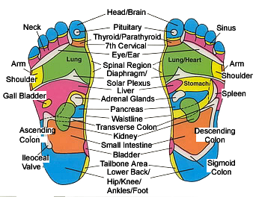

Common discomforts relieved  Headaches  Neck, Shoulder,Wrist  Sleep problems  Indigestion  Lack of Energy  Feelings of Imbalance  Blood Pressure  Pregnancy Issues Menopause  PMT | Assists with Preparation for:  Childbirth  Pregnancy  Fertility  Operations  Immunity  Detox  De-stressing the body  Dealing with Trauma  Clear Thinking  Goal Setting
See over page for contact details……

better well-being through Reflexology…

What is reflexology?
Our hectic lifestyles and increasing responsibilities in life often lead to emotional and/or physical stress. As a result, ‘blockages’ or ‘knots’ of the energy channels in the body occur and often this can lead to common ailments such as back pains, sleep, digestive disorders and lack of energy.
Reflexology can help you better manage health concerns and generally improves the quality of your life by…

- relieving stress and tension
- improving blood and energy supply and circulation in the body
- promoting normalisation of body functions

Your body is then better able to do what it is meant to do……maintain health and well-being.

This is possible because the feet are like a mirror to the body – the reflex areas on the soles connect to different organs and systems of the body, through the nervous, circulation and energy flows.

Reflexology is a method of stimulating and manipulating reflex points, on the ears, hands ands feet. It is a non-invasive therapy which relaxes the body and promotes overall inner balance between the organs, glands and body systems. It helps your body with its self-healing.

By massaging the reflex areas regularly through reflexology, blockages arising from everyday experiences and times of unusual strain (eg., the last trimester of pregnancy, career pressures, illness) can be eased and cleared. This allows energy to flow more freely through the zones of your body. Thus promoting physical and mental well-being!

Who will benefit from reflexology?
Everyone! Regular treatments promote overall well being and help to manage or even alleviate a diverse range of common concerns such as:

- Back pains  - Blood pressures abnormalities  - Burn out and stress  - Digestive problems  - Energy levels  - Fertility  - Heel spurs  - Migraines | - MS management  - Muscular aches & pains  - Pre & post natal stress  - Pregnancy discomforts  - Preparation for Childbirth  - PMT  - Sinus
Don’t wait for something to ‘go wrong’!
Regular sessions assist in maintaining general well-being

What will I feel after a reflexology treatment?
Many clients exclaim, "I feel re-energised from head to foot!" at the end of their treatment as they bounce out of the clinic. This simply reinforces that reflexology is a revitalising therapy, replacing ho-hum and tiredness with a renewed zest for life. Some of the positive after-effects are:

- Refreshing deep sleep | - Clarity of thoughts
- Renewed energy | - Improved concentration
- Internal & external harmony | - Greater awareness of body & soul needs
Registered with most Health Funds
HOME TREATMENTS AVAILABLE
For appointments: Contact Tel Mob: 0421 646 137 Stephen O’Rourke

